**NANDHA ENGINEERING COLLEGE**

**(Autonomous Institution)**

Erode-638 052



**TABLEAU - TWO CREDIT COURSE**

**IV – Semester**

**B.Tech - Artificial Intelligence and Data Science**

**NAME : S.JANANI**

**REG.NO : 23AI023**

**BRANCH : B.TECH AI&DS**

**YEAR : II**

**TABLEAU**

* Tableau is a data visualization tool.
* Used for analyzing and visualizing data through interactive dashboards and reports.
* Allows easy creation of charts, graphs, and maps.
* Connects to various data sources (Excel, databases, cloud services).
* Helps in identifying trends, patterns, and outliers in data.
* Known for a user-friendly, drag-and-drop interface.
* Supports real-time data analysis and updates.
* Popular in business intelligence and data analysis fields.
* Can be used for both individual and collaborative data analysis.

**OVERVIEW OF THE PROJECT**

The goal of this project is to analyze customer marketing data collected from various sources to uncover insights about purchasing behaviour, customer demographics, and sales trends. The final output helps in understanding which customer groups are most valuable, how demographics influence buying decisions, and what marketing strategies could drive better sales performance.

**Global Education Distribution Map(2012-2014)**

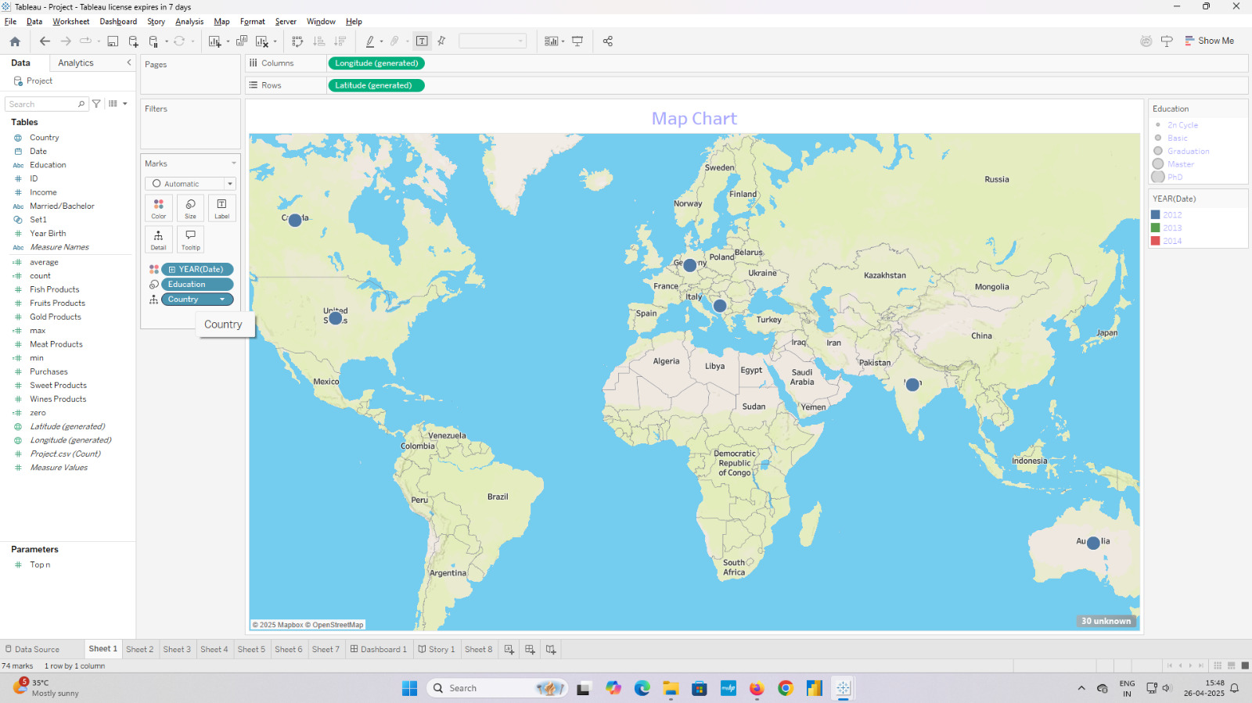

* The visualization represents a map chart titled "Global Education Distribution Map", created using Tableau.
* Latitude and Longitude are used for positioning, with YEAR(Date) in the Columns shelf for temporal differentiation.
* Filters include Country and Education level(e.g., 2nd Cycle, Basic, Graduation, Master’s, PhD) to refine the dataset.
* Education level determines marker size, YEAR(Date) sets the color(2012 : blue, 2013 : purple, 2014 : red), and data points are plotted globally.

**Fish & Fruit Consumption Vs Income**

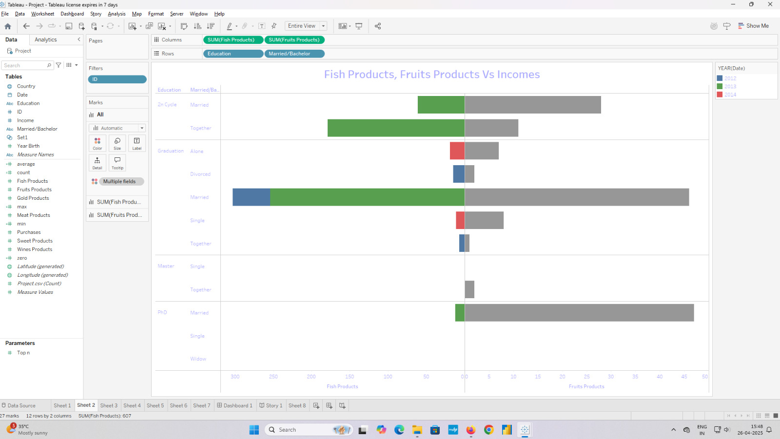

* The visualization titled "Fish & Fruit Consumption Vs Income" is a butterfly chart created using Tableau.
* The Columns shelf contains SUM of Fish Products and SUM of Fruits Products, split by year.
* The Rows shelf includes fields like Education and Married/Bachelor status to categorize data. twice, while no fields are placed in the Rows shelf.
* The Filters applied are Action (Precinct), Action (City), and Action (Object Id), which allow users to refine the displayed data.

Education Level Distribution by Product Consumption

**Education Level Distribution By Product Consumption**

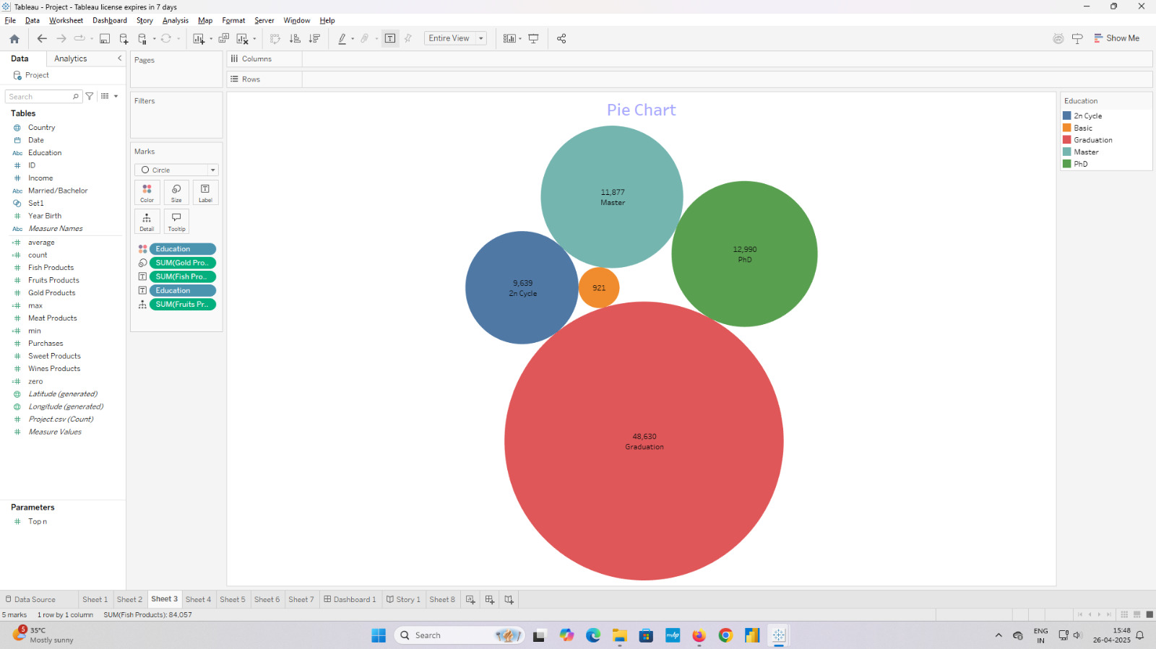

* The visualization titled "Education Level Distribution by Product Consumption" is created using Tableau.
* A Circle View (Packed Bubbles) chart is used, where each circle represents a different Education category.
* The size of each bubble is determined by the SUM of Gold, Fish, and Fruits Product purchases.
* Colors are assigned based on Education Level (e.g., Graduation, Master, PhD) for clear differentiation.

**Monthly Purchases by Year (2012-2014)**

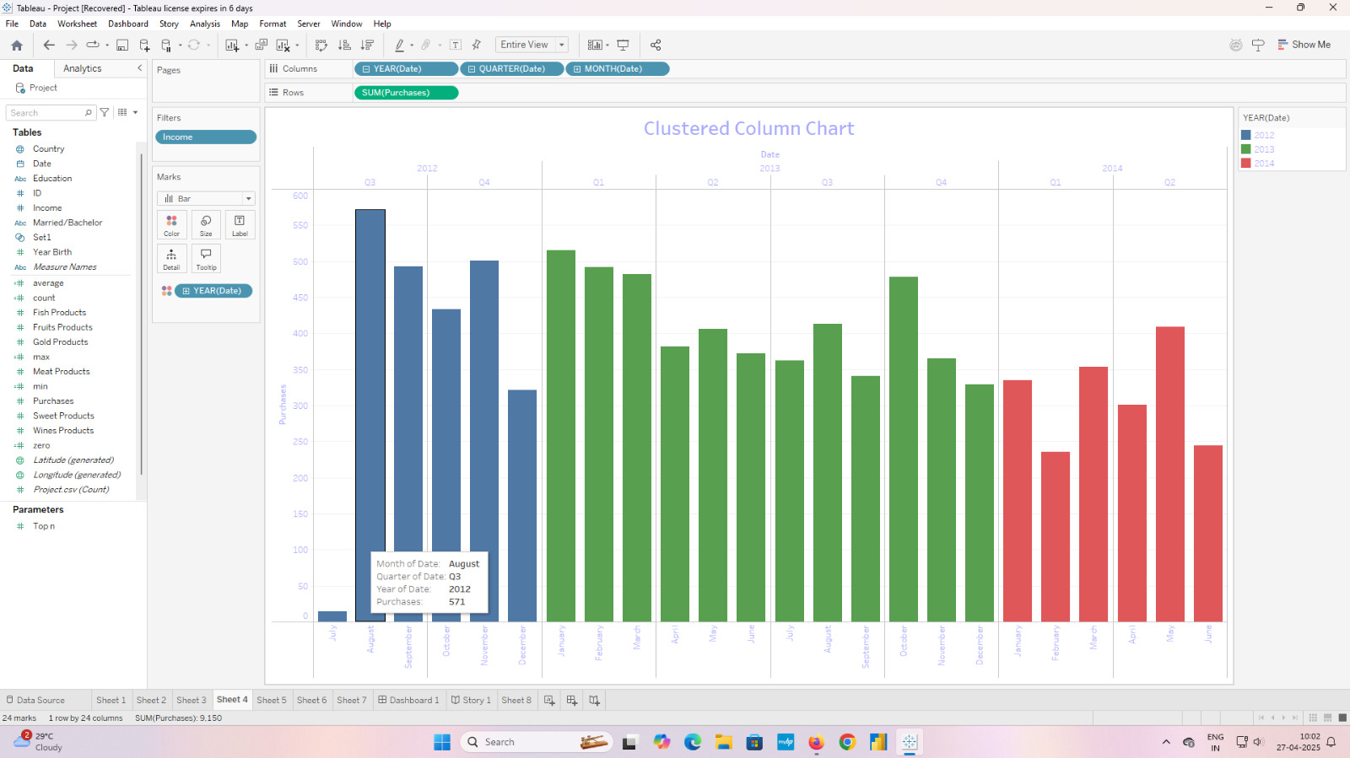

* The chart displays monthly purchase totals across three years: 2012 (blue), 2013 (green), and 2014 (red).
* Purchases peaked in November 2012 with 571 units, the highest recorded value.
* There is a noticeable decline in purchases from 2013 to 2014 across most months.
* Seasonal trends are evident, with higher purchases typically occurring in the latter half of each year.

**Purchases by Marital Status and In/Out Set :**

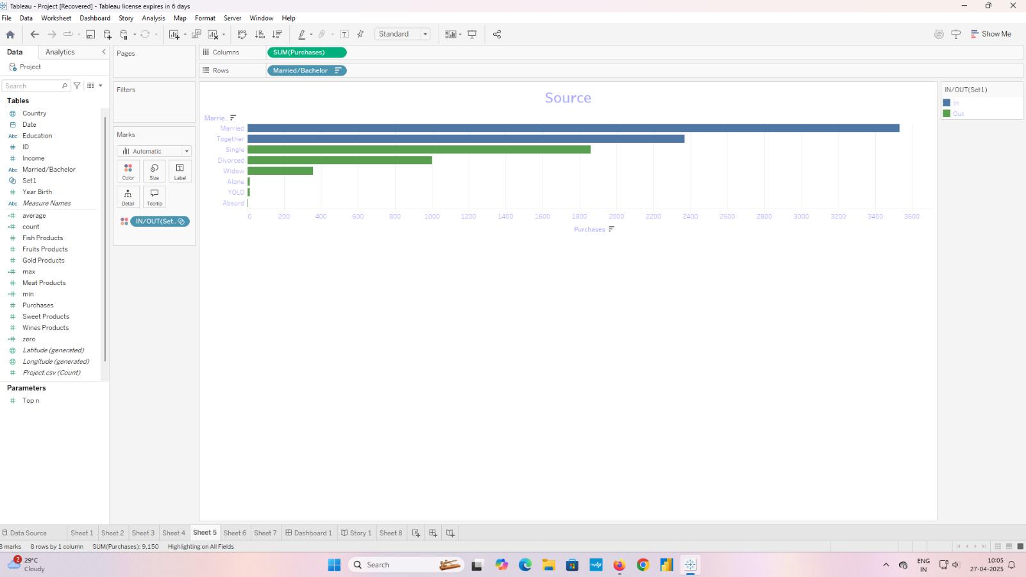

* The chart displays monthly purchase totals across three years: 2012 (blue), 2013 (green), and 2014 (red).
* Purchases peaked in November 2012 with 571 units, the highest recorded value.
* There is a noticeable decline in purchases from 2013 to 2014 across most months.
* Seasonal trends are evident, with higher purchases typically occurring in the latter half of each year.

**Gold Products Consumption by Education Level**

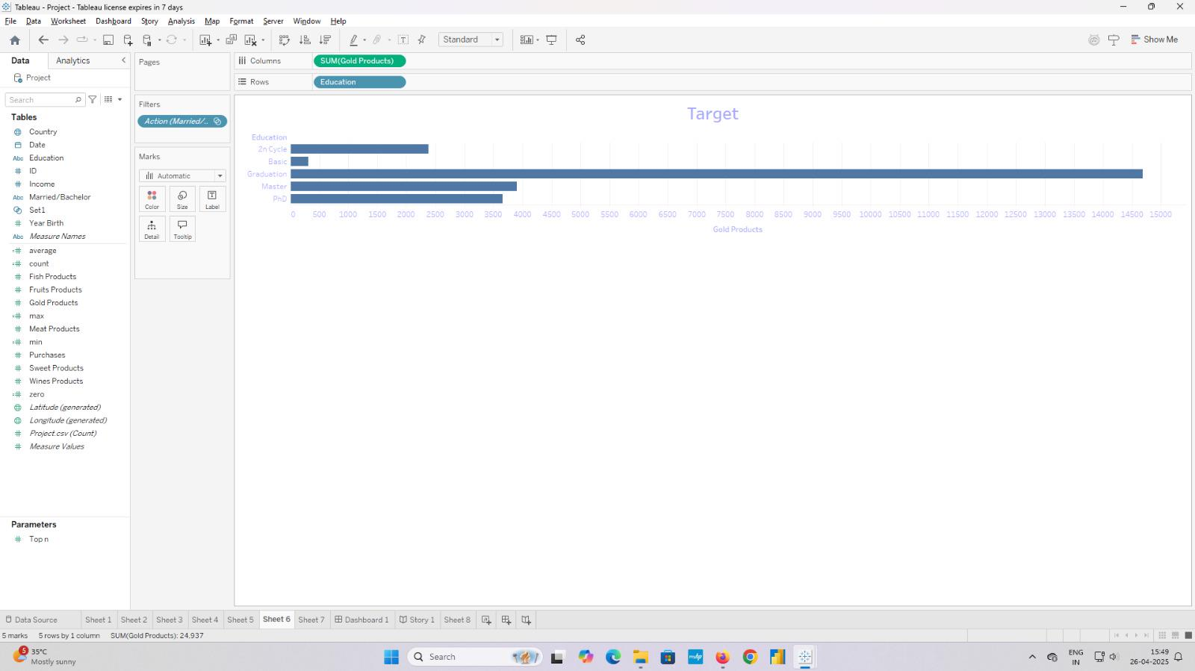

* The visualization titled "Gold Products Consumption by Education Level" is created using Tableau.
* A horizontal bar chart is used, where each bar represents a different Education category.
* The length of each bar reflects the SUM of Gold Products purchased by individuals with that education level.
* A Filter on Marital Status (Action Married/Bachelor) is applied to narrow down the data.

**Distribution of Purchases by Education Level**

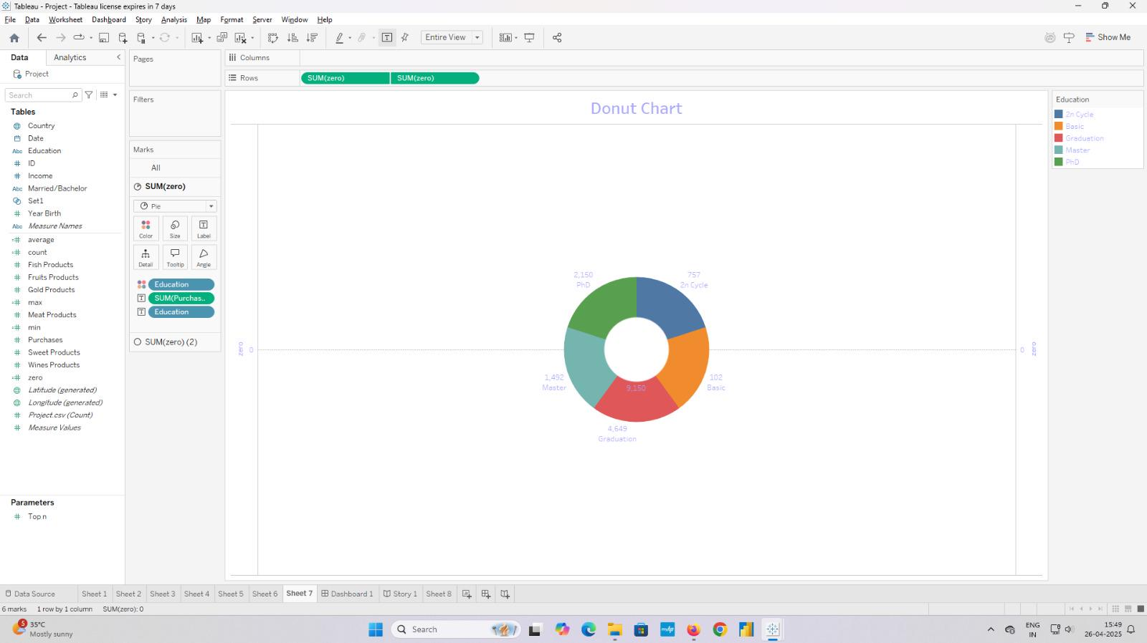

* The chart compares total purchases (SUMPurchases) across marital statuses (Married, Together, Divorced, Widow, Alone, YOLO, Absurd) and In/Out sets (In: blue, Out: green).
* The "Married" status has the highest purchases, with the "In" set exceeding 3,500 units, significantly more than the "Out" set at around 1,500 units.
* The "YOLO" status shows the lowest purchases, with both "In" and "Out" sets below 500 units.
* Across all marital statuses, the "In" set consistently has higher purchase totals compared to the "Out" set.

**Monthly Purchase Totals (2025)**

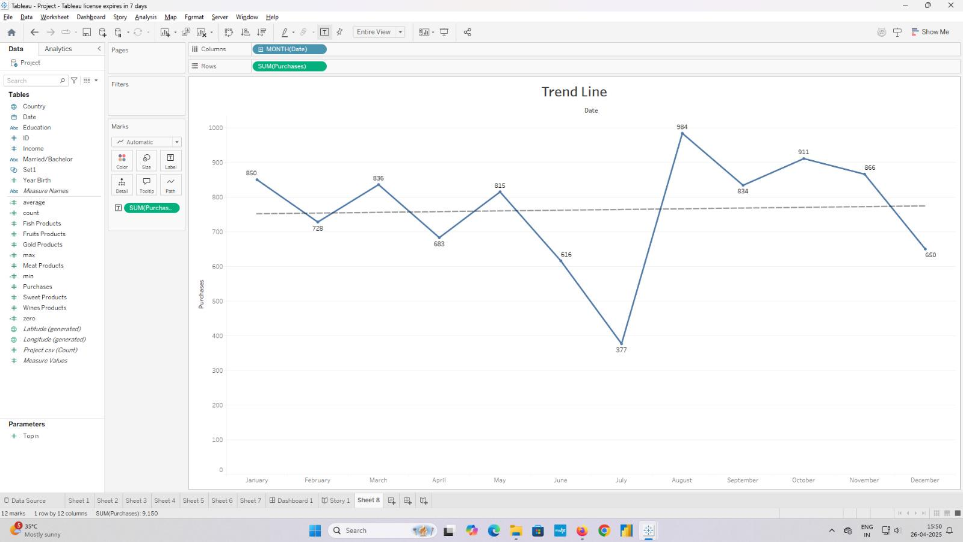

* The chart shows monthly purchase totals (SUMPurchases) with a peak of 911 units in September 2025.
* The lowest purchase total is 377 units in July 2025, indicating a significant dip mid-year.
* Purchases generally trend upward from April (616 units) to September (911 units), followed by a decline to 650 units by December.
* The dashed line represents the average purchase total, hovering around 800 units across the year.

**Global Purchase Analysis by Education, Source, and Product Trends (2025)**

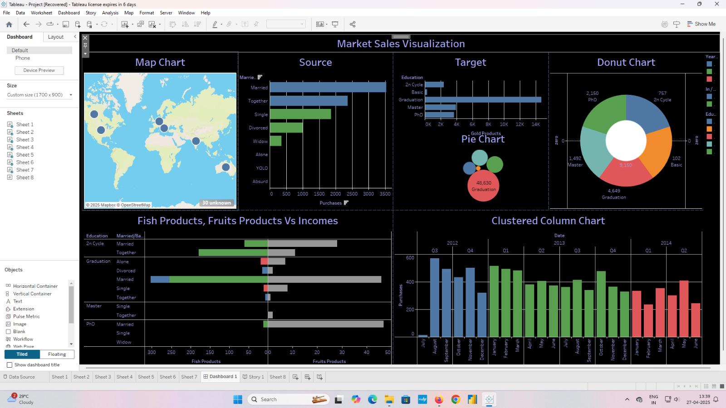

**Understanding & Conclusion:**

* Graduation" education level leads purchases, especially in gold products, with 4,548 total units.
* Purchase clusters are prominent in North America, Europe, and Australia, per the Map Chart.
* "Married" marital status shows the highest purchase activity, exceeding 3,500 units in the "In" set.
* A decline in purchases from 2012 to 2014 suggests potential market shifts needing 2025 analysis.